**Heart Disease Prediction Project**

**Overview**

This project utilizes advanced machine learning methods to predict the probability of heart disease using the Heart Disease dataset from [Kaggle]. By examining critical health metrics and fine-tuning predictive models, the goal is to provide an effective solution for early detection and risk evaluation.

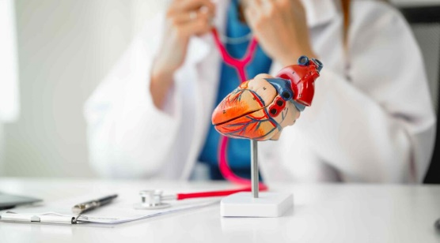

**Dataset**

Use CSV file for this project from Kaggle, that have both male and female data with many attributes to train the data and then predicts using different models.

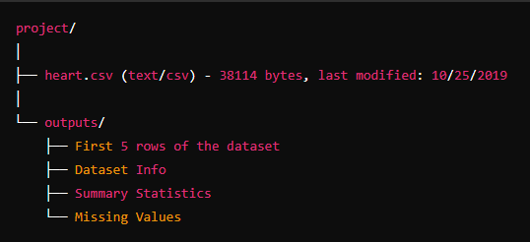

**Libraries**

**What libraries that we used in this project actually.**

* Pandas Ipython
* Numpy
* Sklearn
* Matplotlib
* Seaborn

**Model Training**

We use some models and train them to predict the disease and find the accuracy.

1. **Logistic Regression**

* F1-Score : 0.844262
* Accuracy : 81.990521
* Precision : 0.811024
* Recall : 0.880342

1. **Random Forest**

* F1-Score : 0.995745
* Accuracy : 99.526066
* Precision : 0.991525
* Recall : 1.000000

1. **SVM**

* F1-Score : 0.915966
* Accuracy : 90.521327
* Precision : 0.900826
* Recall : 0.931624

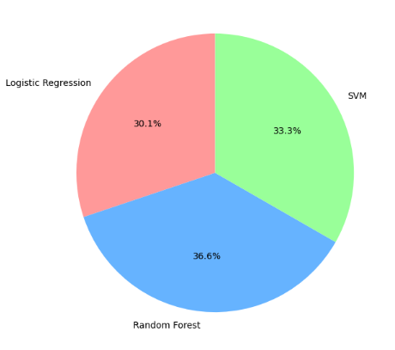

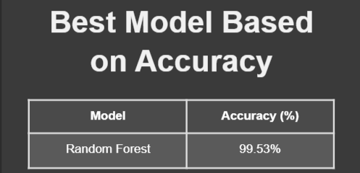 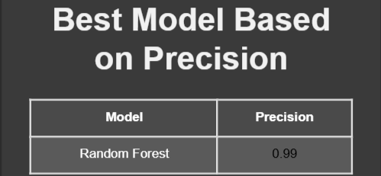 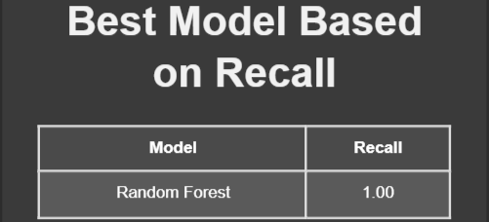 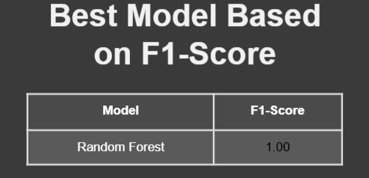

**Objectives of Disease Prediction Using Patient Data**

* Develop machine learning models to predict diseases like heart disease effectively and accurately.
* Leverage data preprocessing techniques to ensure clean, normalized, and well-structured datasets for analysis.
* Conduct in-depth exploratory data analysis (EDA) to uncover insights through feature analysis, correlations, and visualizations (e.g., histograms, scatter plots, heatmaps).
* Train and compare models like Logistic Regression, Random Forest, and SVM to determine the most effective algorithm for disease prediction.
* Evaluate model performance using key metrics such as accuracy, precision, recall, and F1-score.
* Deliver a comprehensive report summarizing data analysis, visualizations, model results, and actionable insights.

**Environment:**

Jupyter Lab (4.3.4)

From Anacona (24.11.3)

Python (3.12.3)

**Testing:**

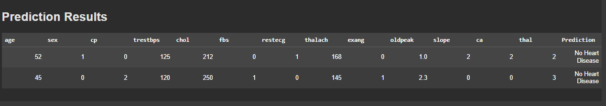

**Project Access**

**Google colab link :**

[**https://colab.research.google.com/drive/11_nbAOG2y0A6qnlaw2WnfCPhensDG2Hz?usp=sharing**](https://colab.research.google.com/drive/11_nbAOG2y0A6qnlaw2WnfCPhensDG2Hz?usp=sharing)